Lab 7: Spatial Clustering of NYPD Police Data Points in QGIS

Objectives
- Perform K-distance analysis on NYPD police data points.
- Create heatmaps to visualize crime density.
- Conduct hotspot analysis to identify statistically significant crime clusters relative to census tracts.

Materials Needed
- NYPD police data (typically available as CSV or Shapefile)
- Census tract shapefile for New York City (can be obtained from NYC Open Data or the US Census Bureau)

Part 1: K-Distance Analysis
1. Introduction to K-Distance
- K-distance helps identify clusters by calculating the distance to the K-th nearest neighbor.
2. Instructions
Step 1: Load the Datasets
- Open QGIS.
- Add Police Arrests Data: Go to Layer > Add Layer > Add Delimited Text Layer (for CSV) or Add Vector Layer ().
- Load the NYPD police data layer and the census tract shapefile (make sure to use the Longitude and Latitude as points in loading).
- Projection: Verify that the dataset is in a proper CRS (e.g., Pick EPSG: 2263 (NAD83 / New York Long Island)).
*Go to “Reproject Layer” to change the CRS.

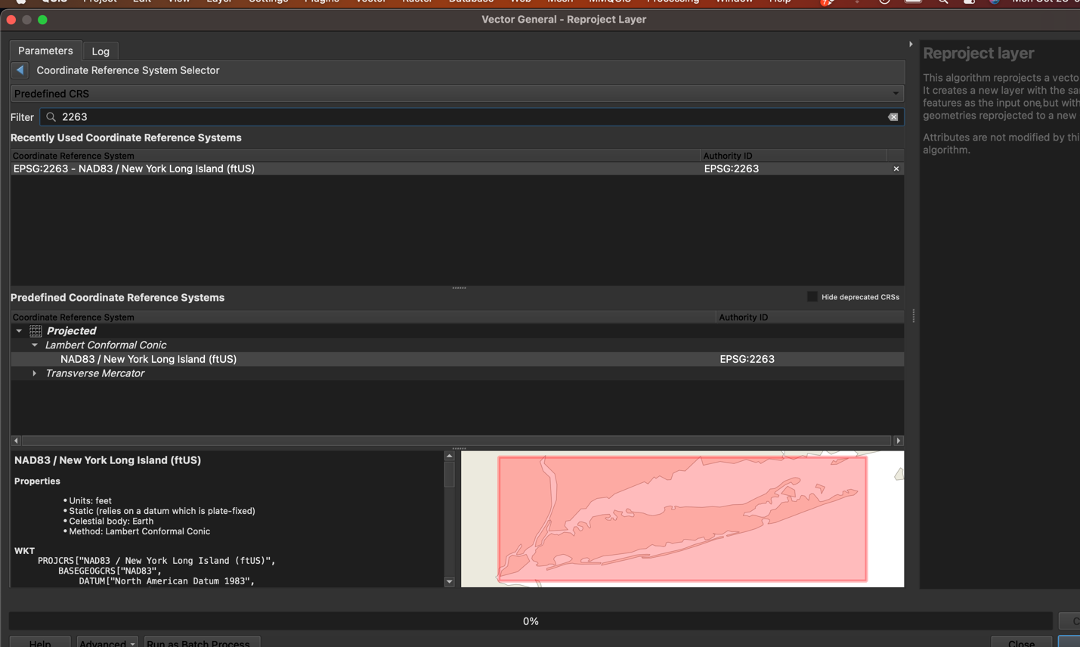

3. Run K-means
- Open the Processing Toolbox and search for "K-means clustering."
- Select the arrest points layer as the input layer.
- Set the number of clusters (e.g., 5 clusters) and run the tool.
4: Visualize K-means Results
- Style the Output Layer: Use the Categorized symbology option to assign different colors to each cluster based on cluster size.
- Visualization Tool: Use the Map Composer to create a layout with a title, legend, and scale bar. This will help students understand cluster distribution visually (for submission but we will move on in the lab).

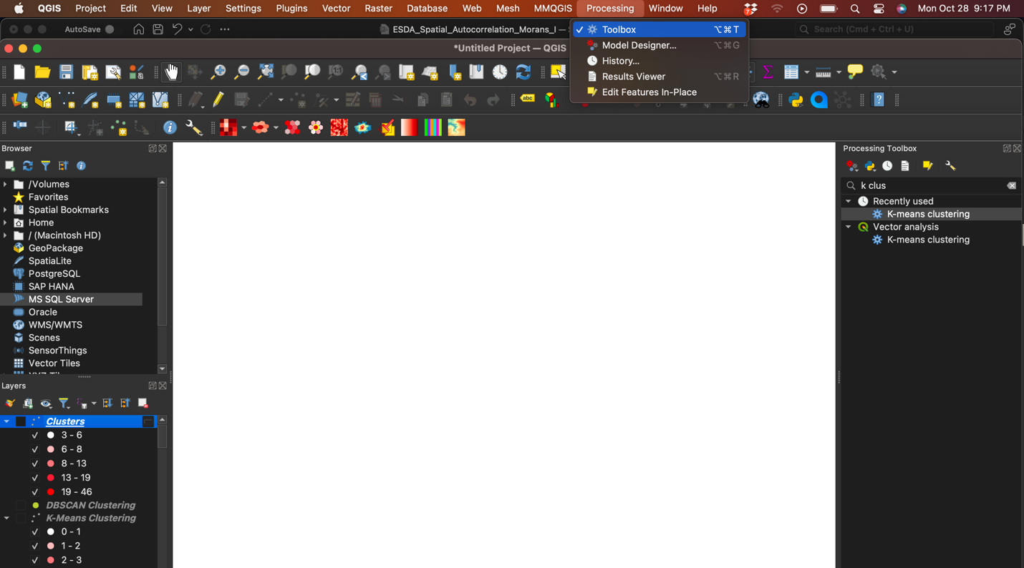

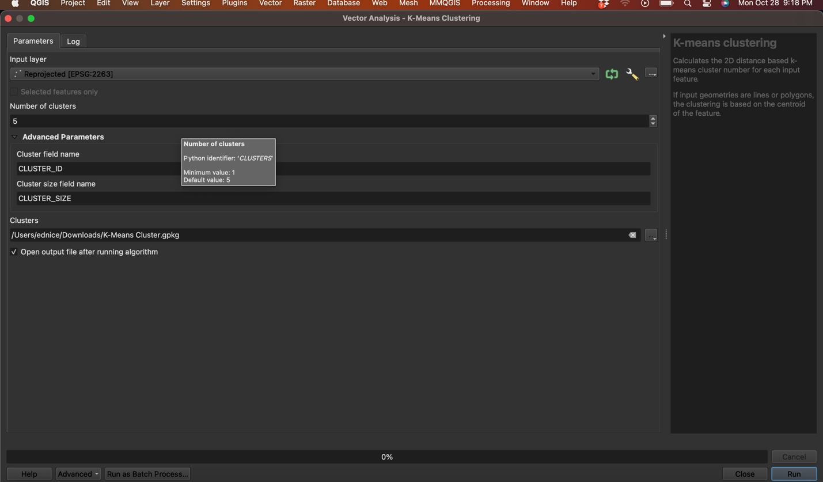

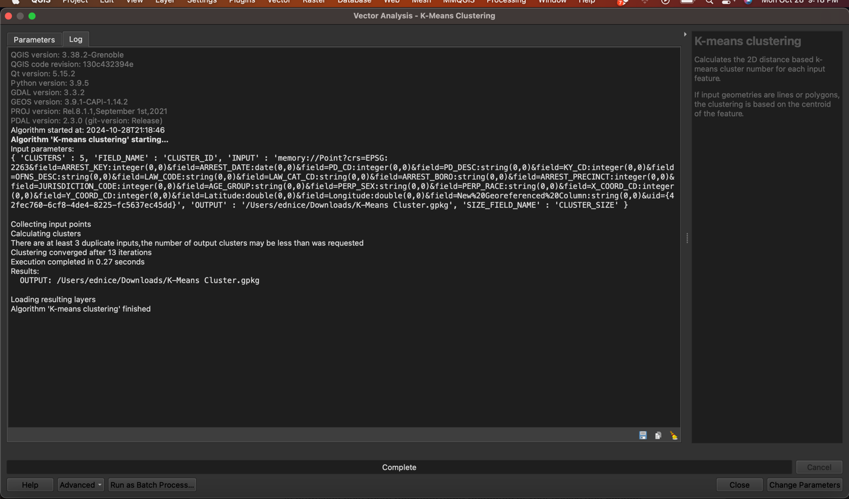

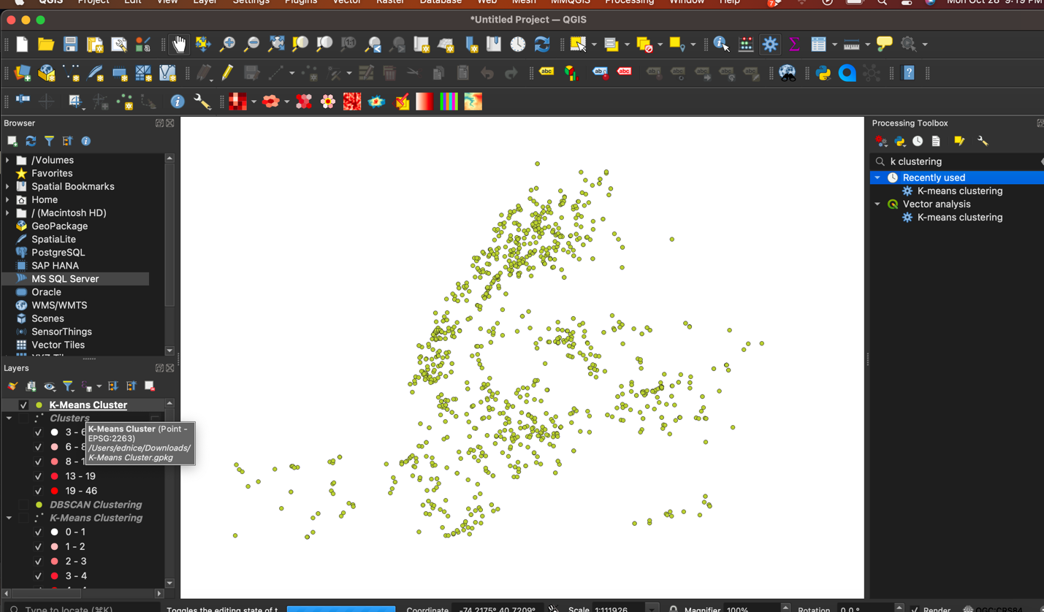

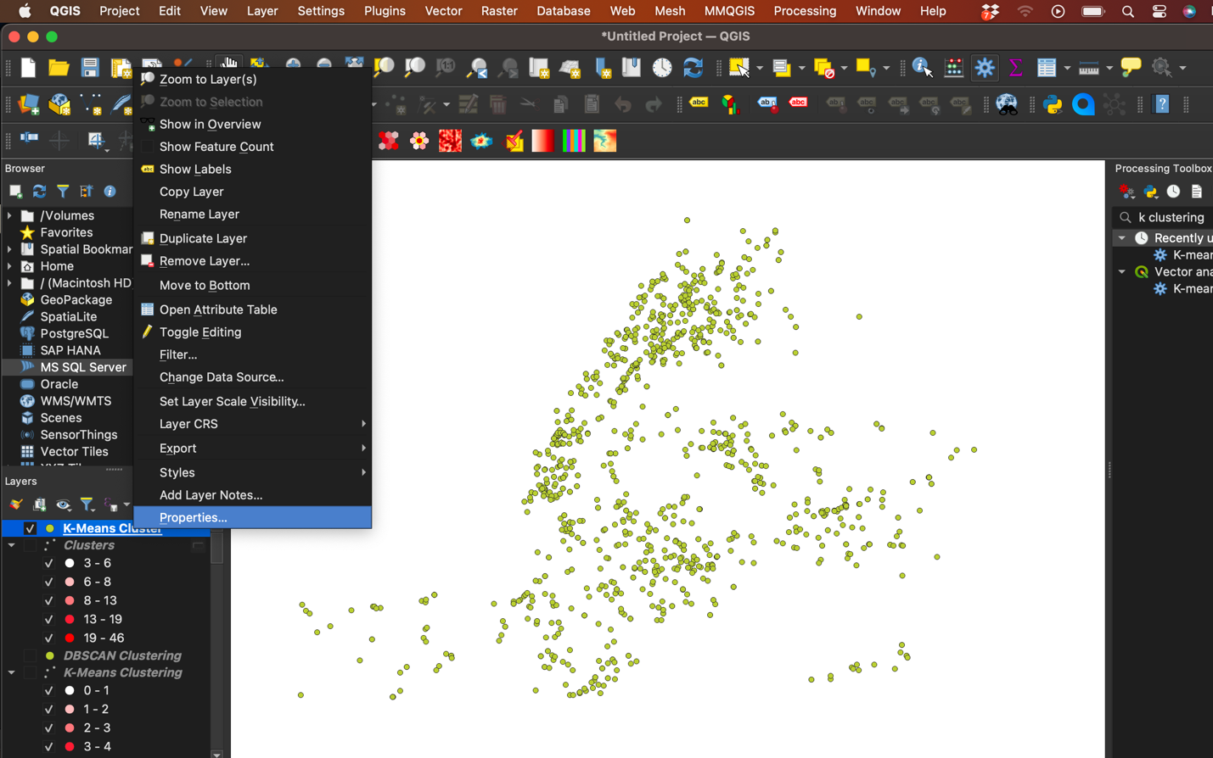

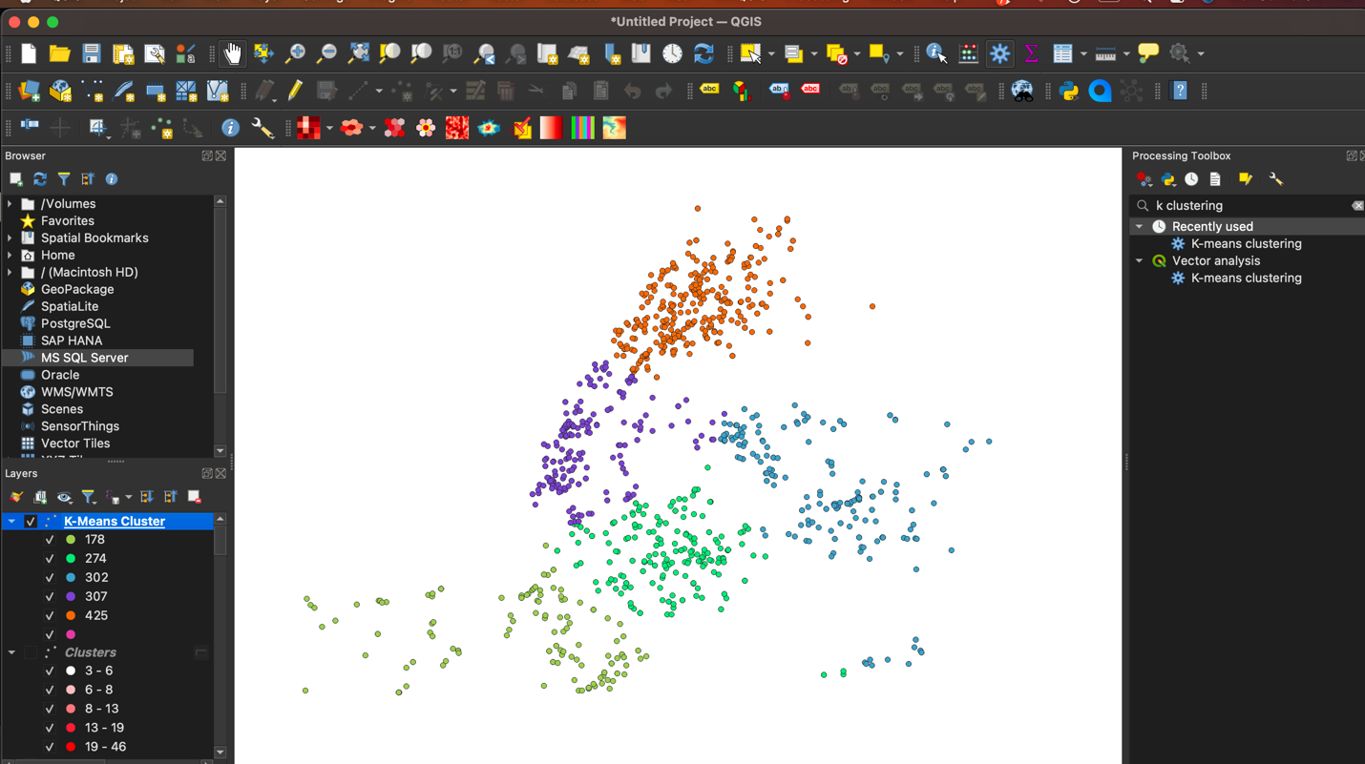

Part 2. Applying DBSCAN Clustering
Step 1: Run DBSCAN
- In the Processing Toolbox, find "DBSCAN."
- Choose the arrest points layer as input.
- Set parameters for epsilon (e.g., 300 meters) and min points (e.g., 5).
Step 2: Visualize DBSCAN Results
- Style the DBSCAN Output Layer: Use Categorized symbology to assign distinct colors to different clusters and a separate symbol (e.g., gray or black) for outliers based on the size of the Cluster Size.
- Visualization Tool: Utilize the Map Composer to create a layout that compares K-means and DBSCAN results on the same map, including side-by-side maps if possible.

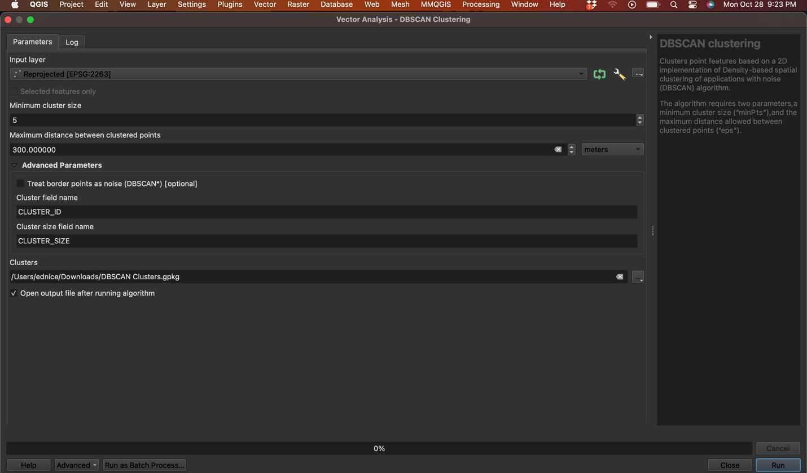

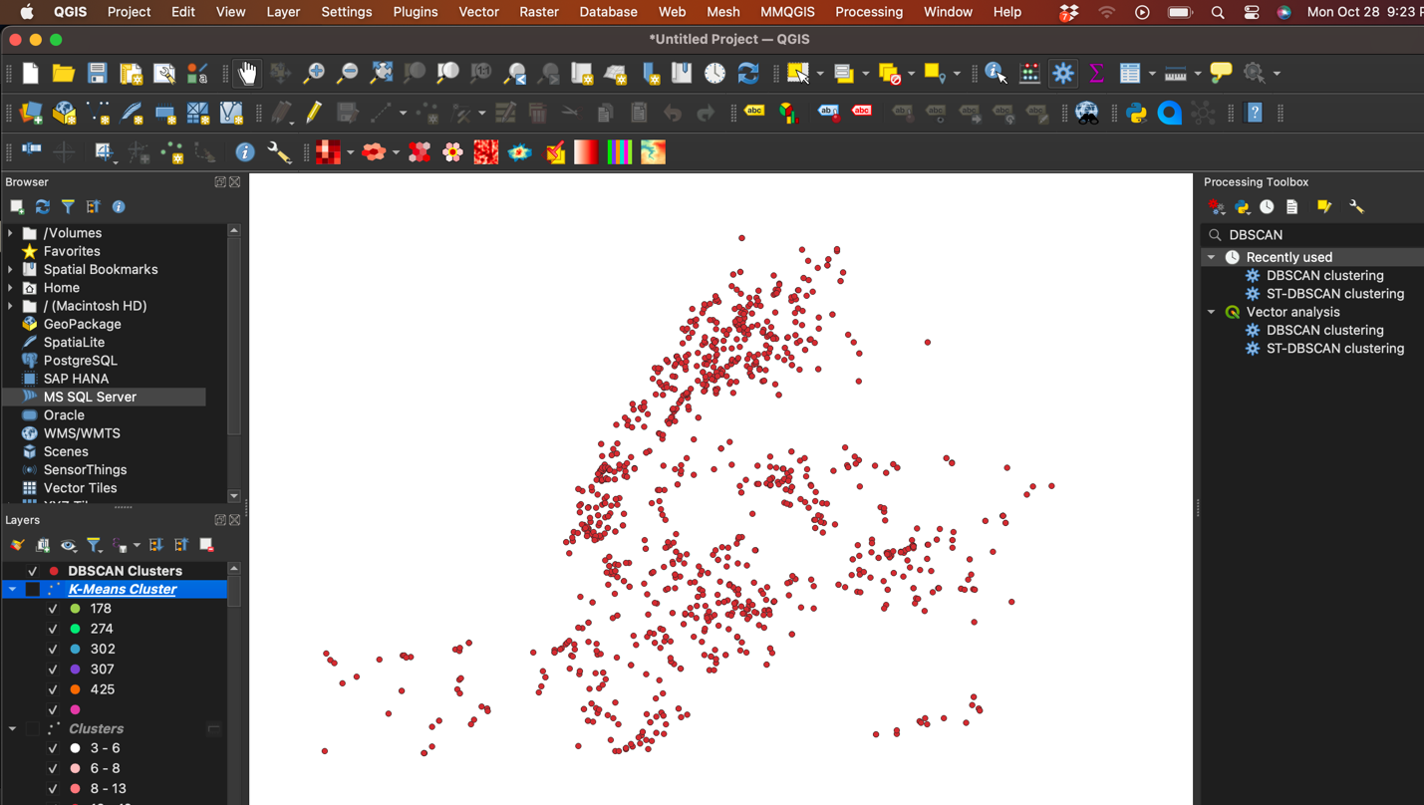

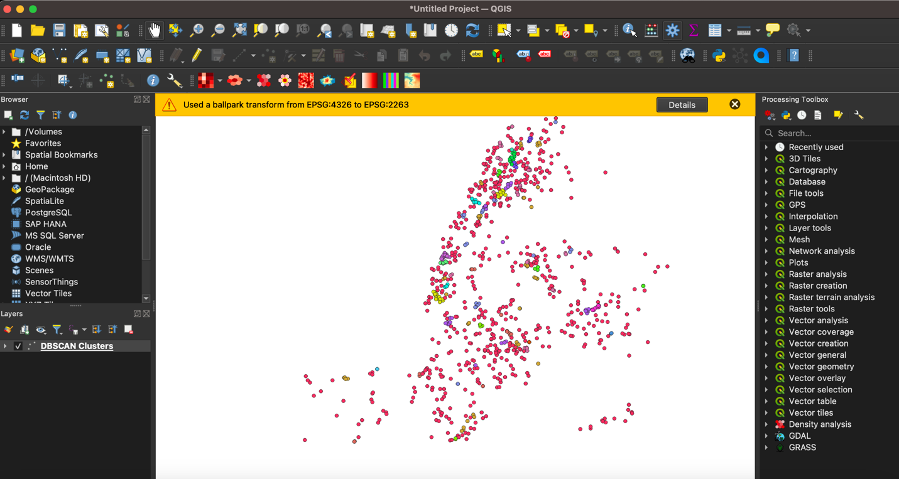

Part 3. Creating a Kernel Heatmap
Step 1: Run Kernel Density Estimation
- Open the Processing Toolbox and search for "Heatmap (Kernel Density Estimation)".
- Select the arrest points layer as the input layer.
- Choose the radius for the kernel density (e.g., 500 meters), which determines the area of influence for each point. Put “500” for Pixel Size X and and put “500” for Pixel Size Y.
- Run the heatmap tool to generate a raster layer representing the density of arrests.

Step 2: Visualize the Kernel Heatmap
- Style the Heatmap: Change the symbology to a gradient color scheme (e.g., from green to red) to highlight areas of high and low density.
- Use Layer Blending: Adjust transparency settings to allow for overlaying the heatmap with the original arrest points or clustering results.

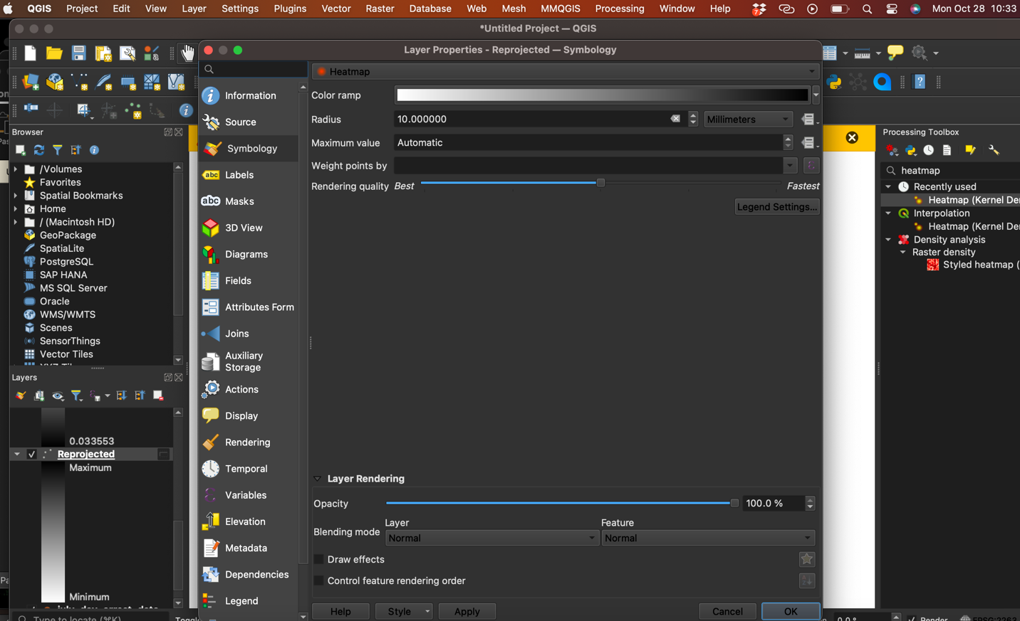

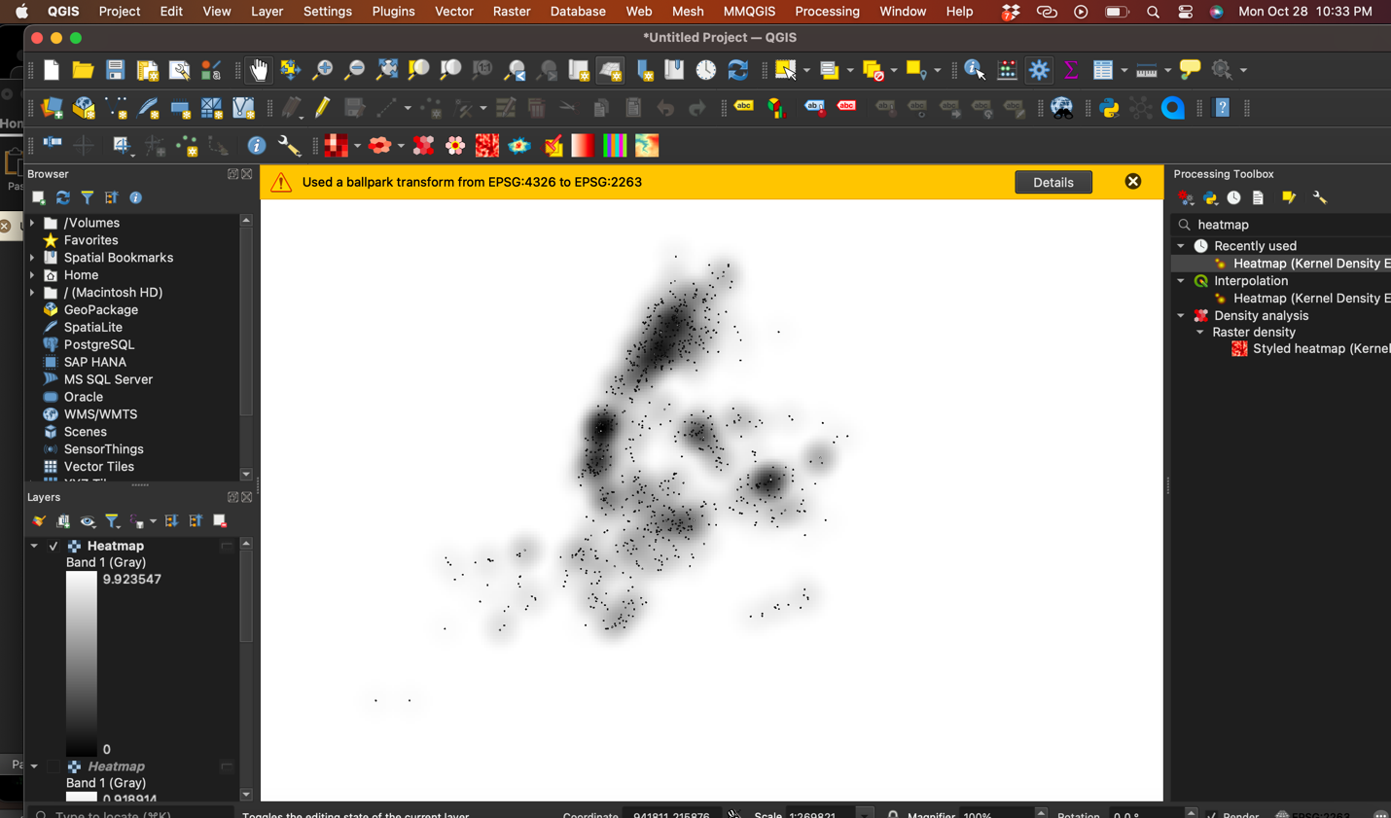

Part 4. Compare to a regular heatmap in QGIS.

- Change Render Type to Heatmap:
  - In the Symbology window, find the dropdown menu at the top (usually set to Single Symbol by default).
  - Change the Reprojected police arrests data to Heatmap.
- Adjust the Heatmap Settings:
  - Radius: Set the radius to a value that suits the scale of your data. For NYC data, try something like 100-500 meters. The radius defines how much area around each point is included in the heatmap.
  - Color Ramp: Choose an appropriate color ramp from the list. Click on the color ramp and select one, such as YlOrRd or Blues, to visualize areas of density.
  - Maximum Value: You can leave it on Auto or adjust the maximum heatmap value manually based on your data distribution.
- Apply and View:
  - Once you're satisfied with the settings, click Apply and then OK.
  - Your heatmap should now appear on the map, showing areas of high and low concentration of arrest points.
  - Make as transparent as possible to see the locations that are clustered together.
Adjusting the Heatmap:
- Radius: Increase the radius for a smoother, more generalized map, or decrease it for finer details.
- Color Ramp: Customize the color scheme to better represent density, making areas with more data points stand out.

Part 5. Comparative Analysis
Visualization Tools:
- Side-by-Side Comparison: Display K-means, DBSCAN, and kernel heatmap outputs in separate but adjacent layouts within the Map Composer.
- Layer Overlay: Have students overlay the kernel heatmap with K-means and DBSCAN results to visualize how the clusters correspond to areas of high density.
Guided Questions:
- How do the cluster shapes and densities from K-means and DBSCAN relate to the patterns seen in the kernel heatmap?
- What insights can be gained from the heatmap regarding the concentration of arrests in specific neighborhoods or regions?
- Which visualization provides clearer insights into arrest patterns, and why?

Due: Submit a one-page assignment to the above questions with the lab by next Tuesday, November 5.

